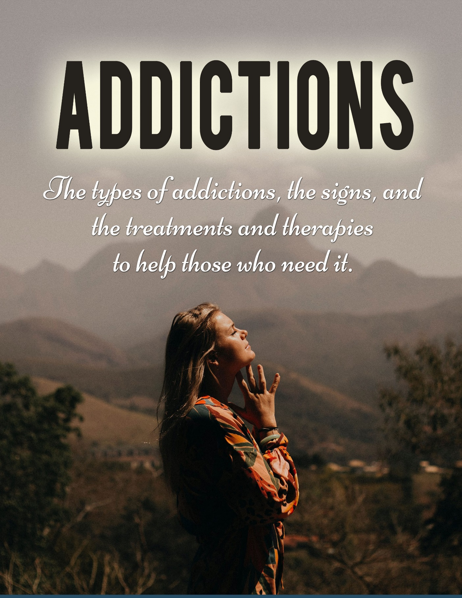

Addictions

Disclaimer 4
Introduction 5
Behavioral Addictions 6
Criteria for Behavioral Addictions 7
Common Behavioral Addictions 8
• Gambling Addiction 8
• Video Game Addiction 8
• Internet Addiction 8
• Sex Addiction 9
• Porn Addiction 9
• Shopping Addiction 9
• Risky Behavior Addiction 9
Addictive Personality 10
What is An Addictive Personality? 11
• Impulsive Behavior 11
• Sensation Seeking 11
• Nonconformity 12
• Dismissive Behavior 12
• Inability to Deal with Stress 12
• Instant Gratification Behavior 12
• Inflated Sense of Self 13
Signs of Being in An Addictive Relationship 14
Are You in An Addictive Relationship? 15
An Extremely Difficult Journey 15
Mentally and Emotionally Fixated to the Relationship 16
Hot and Cold 16
It Feels Like Your Life is Falling Apart 16
You Hide Things from Your Family & Friends 17
Signs You Are Addicted to Toxic Relationships 18
Subconsciously Choosing Partners Who Bring You Down 19
You’re Always the Giver. There’s No Compromise in Your Relationship 19
You Never Get Emotional Support from A Partner 20
You Date People Who Challenge Your Values or Lie to You Constantly 20
You Experience Emotional or Physical Abuse in Your Relationships 20
Chemical and Substance Addictions 21
Addiction is a Disease 22
The Dopamine Game 22
Physiological Effects 23
Psychological Effects 24
Internet, Smartphone and Gaming Addictions 25
Internet Addiction 26
Smartphone Addiction 27
Gaming Addiction 27
Sexual Addiction 29
What is Sexual Addiction? 30
Signs and Symptoms of a Sexual Addiction 30
Are There Risk Factors for Sexual Addiction? 31
Complications and Consequences 31
Shopping Addiction 33
Risk Factors for Shopping Addiction 34
Phases and Type of Shopping Addiction 34
Consequences of Shopping Addiction 35
Treatments 36
Work Addiction 37
Symptoms and Behaviors of Work Addiction 38
Risk Factors 39
Effects and Consequences 39
Treatments and Therapies for Addictions 41
Individual Counseling 42
Inpatient Treatment Centers 42
Outpatient Treatment Centers 43
Support Groups 43
Medications 44
Conclusion 45

Disclaimer

We hope you enjoy reading this publication, however, we do suggest you read our disclaimer.

All the material written in this document is provided for informational purposes only and is general in nature.

Every person is a unique individual and what has worked for some, or even many, may not work for you. Any information perceived as advice must be considered in light of your own particular set of circumstances.

The author or person sharing this information does not assume any responsibility for the accuracy or outcome of your use of the content.

Every attempt has been made to provide well-researched and up-to-date content at the time of writing. Now all the legalities have been taken care of, please enjoy the content.

Introduction

With even a cursory understanding or reflection on human behavior, it is not hard to understand just how vulnerable we are to addiction, in one form or another.

Our daily existence is made possible by whole sets of routines and automatic behaviors on multiple levels.

Most of these have been formed or strengthened with the assistance of naturally occurring hormones that help us to form habits, good or bad, desired or unwanted.

So how much more of a step is an addiction? What defines an addiction, and separates it from a habit?

Basically, an addiction is an extreme compulsive behavior, one over which the sufferer feels unable to resist, even when knowing that the outcomes of fulfilling the addictive behavior will almost certainly have damaging outcomes.

Certainly then, the line between some bad habits and an addiction is not black and white, but a gray area.

This eBook can help you understand what an addiction is, and whether you may be affected by one of the many different types of addiction. This doesn’t mean you may be addicted yourself, but if someone you care about is, you will certainly be affected in one way or another.

Behavioral Addictions

Addiction is a complicated subject. More often than not, people assume addiction is related mostly to substance or chemical abuse. While substance and chemical abuse is very real and affects millions of people every year, we also must acknowledge behavioral addictions.

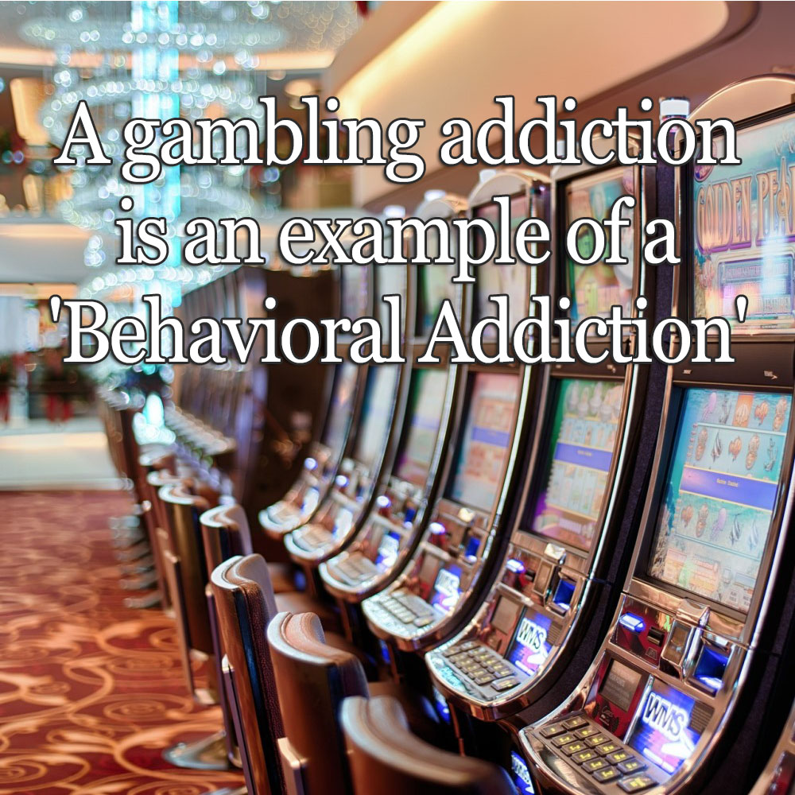

Generally speaking, addiction starts out the same. People are looking for a getaway from life’s ups and downs and begin experimenting with different substances or activities to avoid dealing with the stress at hand.

People partake in tons of activities on a daily basis, each with their own consequences. Seemingly harmless activities become behavioral addictions when the brain interprets the activity as good.

Not just good, but extremely good. The endorphin levels go into overdrive and people crave the high or euphoria created by the stimulation, or activity.

When the activity is carried out compulsively despite negative consequences or guilt in the aftermath, it becomes a much bigger problem. Thus, the birth of a behavioral addiction.

Criteria for Behavioral Addictions

Of the most common behavioral addictions there really is no set diagnostic criteria, except for Gambling Addiction which has finally made it into the DSM-V (Diagnostic and Statistical Manual of Mental Health Disorders, Fifth Edition).

However, mental health professionals will ask a number of questions to delineate whether the behavior is actually an addiction, questionable behavior that is not a clear addiction or normal behavior.

Some of their questions might include:

- Are you spending an inordinate amount of time thinking about, engaging in or recovering from the behavior?
- Are you using the behavior as a means of coping with emotions or stressors?
- Do you continue the behavior despite negative consequences to your physical and/or mental health?
- Do you find yourself neglecting other responsibilities, such as work, school, or family, so you can engage in the behavior?
- Have you tried to stop the behavior and have been unable to do so?
- When you attempt to stop the behavior do you experience withdrawal symptoms such as irritability or depression?
- Do you tend to minimalize the behavior by trying to convince yourself and others it is not a problem?

Common Behavioral Addictions

Behavioral addictions can easily spin out of control wreaking havoc in every area of a person’s life. There’s no possible way to create a comprehensive list of all behaviors which might be considered a true addiction. However, below is a list of several common behavioral addictions.

Gambling Addiction

This includes any and all types of gambling; casino slot machines, poker games, online gambling sites, and betting on sports teams are just a few. People with gambling addiction will place bets often, even if they don’t have the means to cover it. When untreated this addiction will ultimately lead to financial ruin and legal complications.

Video Game Addiction

The allure with video game addiction is in creating a new life, a fantasy life, to avoid the problems of here and now. With the advancements in graphics and the ability to communicate with other players via headset, there’s no need for the outside world.

The bigger issue with this behavioral addiction is the propensity to neglect one’s own health and inadvertently isolate oneself from human interaction. The game essentially replaces the need for healthy relationships and extinguishes the desire to carry out normal activities of daily living.

Internet Addiction

It’s all about being “connected” with this behavioral addiction. Compulsively checking emails, looking at breaking news stories, scrolling through social media feeds, interacting in chat rooms, reading blog posts, researching any- and everything mentioned in normal conversation are a few ways one with an internet addiction might behave.

They feel lonely and as if they are missing out if they aren’t engaging in some form of connection to the internet 24/7.

Sex Addiction

Sometimes confused with a porn addiction, those with this behavioral addiction seek out engagement in anonymous sex, sex with multiple partners, or taboo sex acts. It is also commonplace for those with a sex addiction to refrain from protection thus exposing themselves and others to STDs.

Porn Addiction

This behavioral addiction usually starts small and builds over time by watching porn here and there until ultimately the individual cannot be aroused by one-on-one sex with a partner without the use of porn. Paying more than the budget allows on watching porn is inherent.

Shopping Addiction

The thrill of acquiring something new fills a perceived void in the people with a shopping addiction. There is usually a justification, “excuse”, for buying each purchase as well. It’s either for a gift, a deal that couldn’t be passed up, it will be useful one day or you can never have too many of these. This behavioral addiction becomes a problem when the spending causes financial ruin and purchases are simply forgotten about and just taking up space.

Risky Behavior Addiction

Pure adrenaline rush is what these folks are pursuing. Those with risky behavior addiction will engage in potentially dangerous activities ranging from skydiving to driving under the influence to having unprotected sex with strangers.

There are those who debate whether a behavior can actually be an addiction. They assume the one exhibiting the behavior should just have “a little more self-control”. The fact remains, if self-control were the only issue, those who have succumbed to the behavioral addiction would simply stop before it causes mass chaos and ravages their physical and mental health, ends relationships, or causes a plethora of financial and/or legal problems.

Addictive Personality

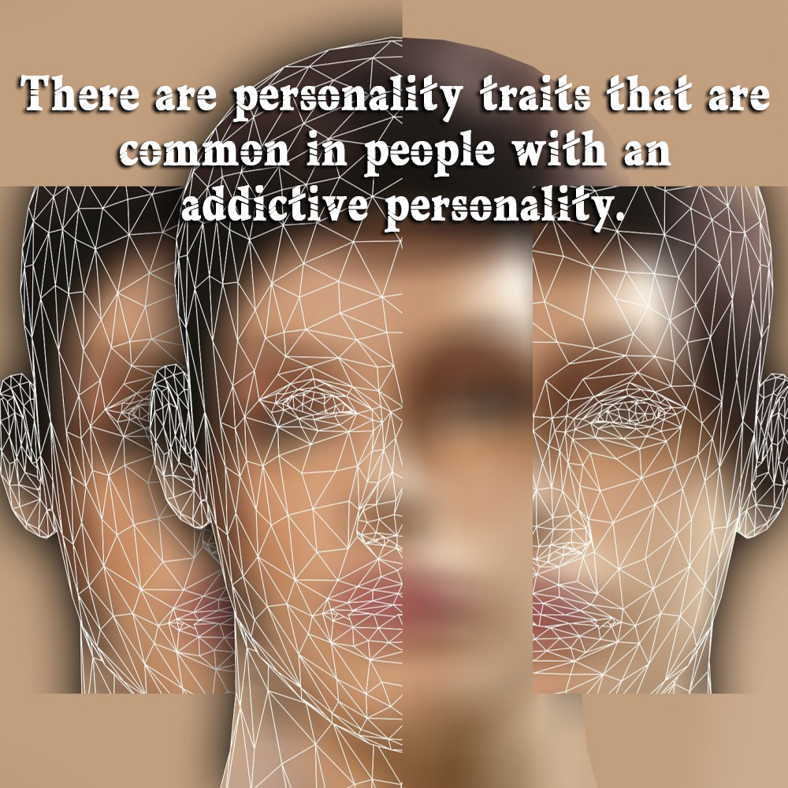

Regarding personality, it is safe to say every human being is different. Although some of our backgrounds might be similar, the exact childrearing and development are different.

Likewise, throughout lives we all have different experiences.

These experiences have molded and shaped us into the people we are today. That said, an addictive personality has many facets and is impossible to limit to a single definition.

What is An Addictive Personality?

Why can one person have 2 glasses of wine with dinner and stop while another wants to open a second bottle after finishing the first?

How can some people use prescription drugs for sleep or pain as prescribed and intended, but others swallow more than the prescribed amount?

An addictive personality can be generically defined as a set of personality traits which when one or more are present, in combination with genetic connections and environmental factors, it can increase the propensity for addictive behaviors.

It should also be understood that just because someone might have one or more personality traits common with an addictive personality, it does not automatically mean they will fall victim to addiction.

However, it would befit that person to pay careful attention to the possibilities of addiction to addictive substances and/or activities.

The following personality traits are common in those with an addictive personality:

Impulsive Behavior

Often referred to as “black and white thinking”, someone with impulsive behaviors often makes drastic decisions without processing consequences.
Doing things in moderation goes out the window and there is somewhat of an “all or nothing” thought pattern. Staying out drinking and partying all night even though there is a big meeting tomorrow morning is a good example.

Sensation Seeking

Adventurous, risk-taking behavior is common in those with an addictive personality. People with this trait exhibit very little impulse control while also being unafraid to try new and even dangerous activities.
This group might also be called “adrenaline junkies” as they are typically looking for that dopamine rush with each experience.

Nonconformity

This personality trait seems to go against the grain just for the heck of it. There’s no real reasoning other than the desire to be different than the norm. People who fit in this group are easily identified as they tend to be reclusive and loners.

Their need to be nonconformists usually points them in the direction of taboo and illegal activities to shun societal norms and trends. However, should one with this personality trait succumb to addiction, it would be less noticeable because of their social alienation.

Dismissive Behavior

People with this personality trait refuse to take responsibility for anything negative. They tend to blame-shift and truly believe there is no fault in their ways or how they have contributed to the issue at hand.

Once an addiction has started, the denial is very real. They are quick to dismiss the idea that they might in fact have a problem.

Inability to Deal with Stress

In understanding the core of addiction, there is almost always an underlying issue that’s being dodged. People exhibiting the inability to deal with stress oftentimes turn to an addiction as a coping mechanism.

This form of self-medicating provides a focal point for an addict other than the source of turmoil, even if only temporarily.

Instant Gratification Behavior

Sometimes we are all a little impatient. Technological advances and social media have helped pave the way for this behavior trait.
Just about anything is only a swipe away. People with instant gratification behavior patterns need results immediately. That’s pleasing to them.

It’s incredibly easy for people with this personality trait to become addicted to any number of things or activities which create an immediate release or high. Being on a high isn’t quite enough for them; it’s also in how fast the high is delivered.

Inflated Sense of Self

An ego is a powerful beast. When there is an inflated sense of self, there is also an inherent difficulty in asking for help. Admitting defeat or failure is simply not in the equation.

Couple that with the general lack of trust and there is a great risk for addictive personality. Being self-sufficient is one thing, but the absolute refusal to seek out help is dangerous and sometimes even deadly in those with addictive personality.

It should be easy now to see how many different faces and angles are involved in an addictive personality. It’s entirely too complex to squeeze into a single definition.

Our society has a hard enough time with the stigma attached to addiction. Limiting the definition creates a continuum of misunderstanding and an uninformed interpretation of addictive behaviors and addiction.

Signs of Being in An Addictive Relationship

Most people dream of having good, loving, healthy relationships in their lives. Unfortunately, even though our society is exposed to great relationship influences, many people still end up in unhealthy relational dynamics.

One type of relationship that is characterized by this undesirable dynamic is an addictive type of relationship.

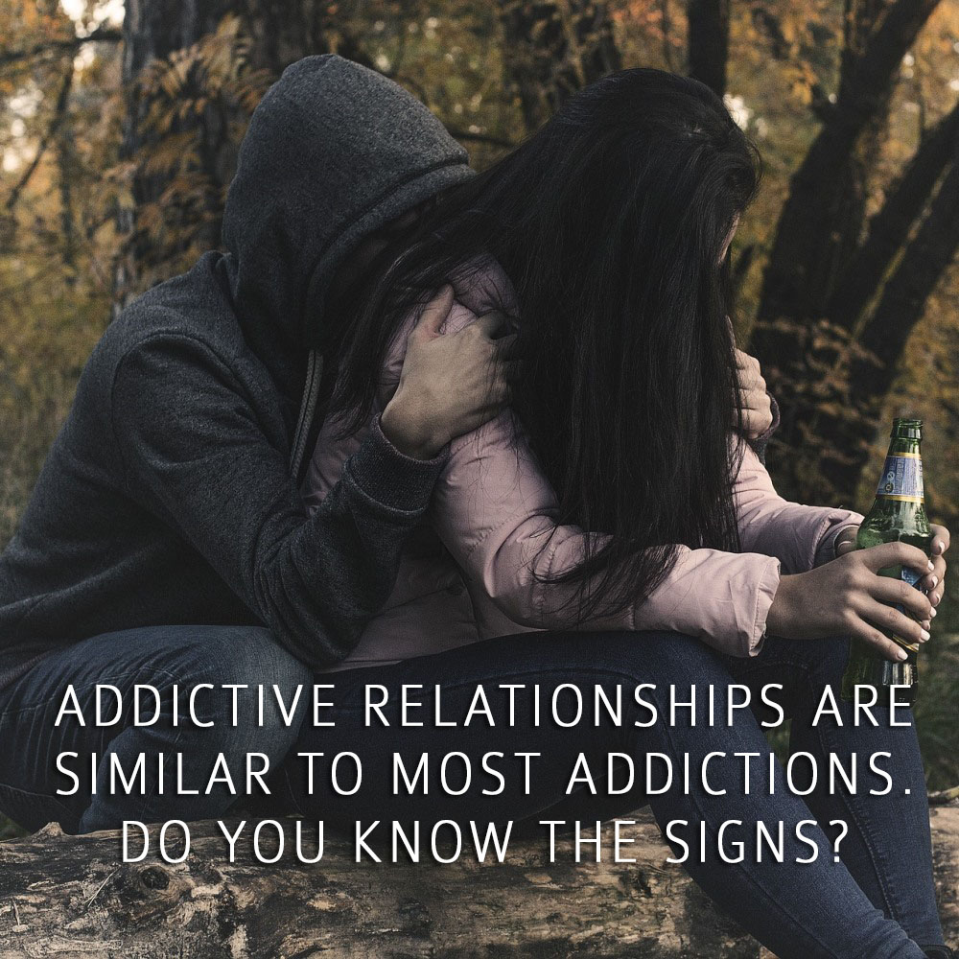

Addictive relationships are similar to most addictions. People get addicted to a variety of things such as smoking, alcohol, drugs, etc. People can also get addicted to love and relationships.

When they are caught in this vicious cycle, they can experience a very unstable and rocky relationship, characterized by consistent negative experiences and emotions, and seemingly insurmountable relationship challenges.

This is not to say that for a relationship to qualify as healthy there shouldn’t be any difficulties at all. Healthy relationships grow with time and eventually get settled and steady, as both partners better understand each other.

Alternatively, an addictive relationship continually strains itself, usually until it breaks.

Are You in An Addictive Relationship?

In your best, highest, most rational moments – do you know this relationship isn’t good for you, but you feel compelled to stay, or can’t break away, or keep getting drawn back in, when you know it is damaging you emotionally?

Here are the telltale signs of an addictive relationship and things to look out for in case you find yourself in one.

An Extremely Difficult Journey

Relationships aren’t expected to be perfect and devoid of any challenges. It’s perfectly healthy to struggle together and come out stronger with your partner, that’s what most relational problems are geared to do.

But being in an addictive type of relationship can feel utterly difficult, and often hopeless. It’s a constant struggle to be together because conflict and drama happen constantly.

Early in a relationship, it is usual for relationship issues to be paramount in your thinking. Are they right for you? Are you right for them? However, as the relationship matures, so too should the feelings that go with it.

Trust develops, not simply about fidelity, but emotional trust in the relationship itself, in all its facets. This doesn’t take away from the strength of the relationship, it adds to it.

Mentally and Emotionally Fixated to the Relationship

However, if you are part of an addictive relationship, the stability of a trusted and trusting relationship does not develop. You are almost always thinking about your relationship, no matter where you are or what you are doing.

This causes you to miss doing important things because you are preoccupied mentally and feeling emotionally jangled most of the time. It can even affect your performance at work and leave you to disregard other important relationships in your life such as friends and family.

Hot and Cold

A hallmark trait of an addictive type of relationship is it feels like a drug. One moment, you’re very happy together, and the next thing, you are in the middle of a heated argument and about to break up, which causes you to feel anxious and depressed.

Ups and downs are normal in relationships, but an addictive one will constantly lift you up high and pull you down extremely low. It’s painful, so much so you can feel physically sick.

It Feels Like Your Life is Falling Apart

Constant drama in your relationship may leave you feeling like your life is falling apart. Being distracted can cause you to neglect other important things in your life.

Everything may seem like it’s falling downhill - friendships may get neglected, work performance may deteriorate, and you will certainly not have any time left for yourself. All your energy will be sapped from you, while you try to make things right.

You Hide Things from Your Family & Friends

You know your relationship isn’t right, yet instead of ending it, you protect it by keeping important things from your family and friends. You try to make things look better than they actually are, not wanting to hear what concerned people in your life might say to you about your relationship.

Losing Grip of Who You Are

Genuine love always brings out the best in people in relationships, in contrast to an addicting one where it’s hard to be yourself and assert your values.

When being in a relationship makes you start to question your values, talk less of your passions and interests, and make you throw personal boundaries out of the window, you are likely entangled in an addicting type of partnership.

Feeling Lonely, Misunderstood, and Unloved

Addicting relationships lack true intimacy. It can likely happen between people who are not aligned with their values, wavelengths, and world view. Despite being in a partnership, you feel more alone, lonely, misunderstood and unloved.

This type of relationship can also make you feel used and not at all valued and seen for who and what you are. If you feel this way about your relationship, then you are in an addicting type of partnership and it’s time to do something about it.

People accept the love they think they deserve. Do you think this is what you deserve?

Signs You Are Addicted to Toxic Relationships

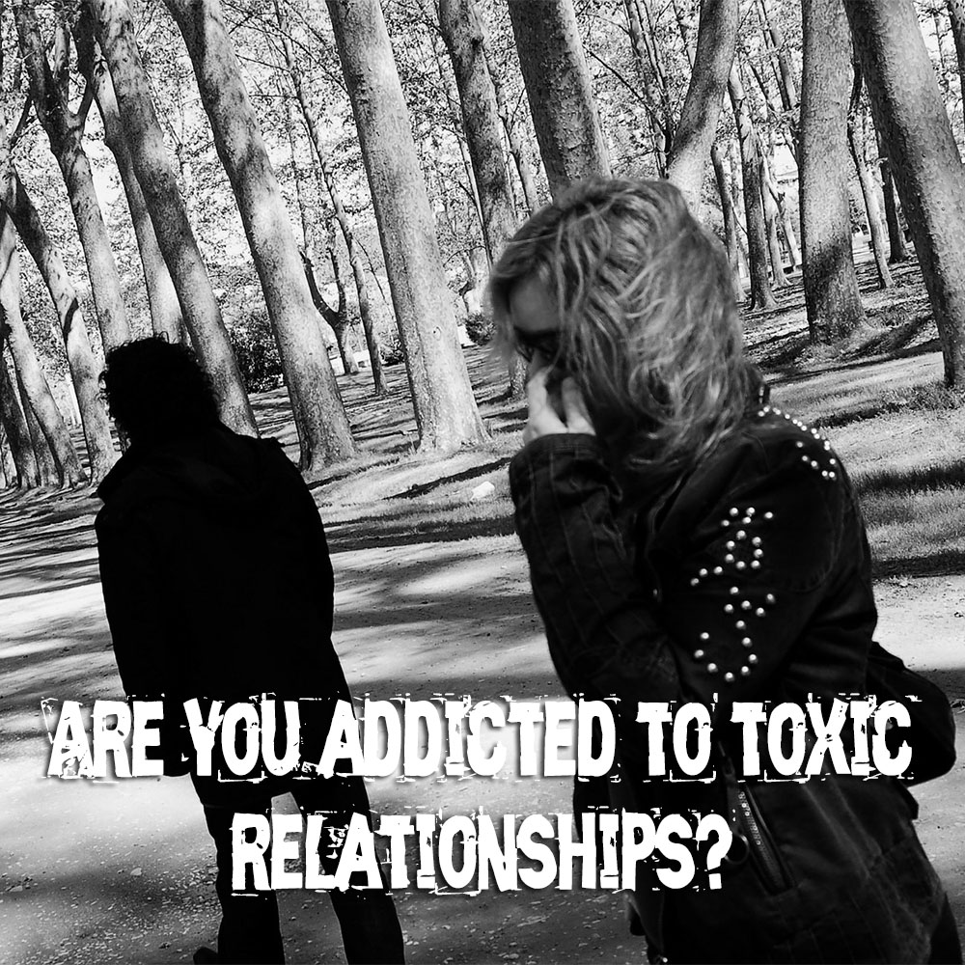

We normally associate the word addiction to a negative, compulsive habit that we cannot stop doing. Often, addiction is largely caused by physical substances that lead to severe compulsions such as drinking, drugs, or smoking.

Relationship addiction follows the same damage-causing pattern as other kinds of addiction. It can also be called love addiction because we justify it as people not acting in their own best interest due to the emotion called love. This type of addiction affects our mental and emotional wellbeing, and it can have damaging effects on our life in general.

It’s a real thing that’s happening to many people in relationships and may be causing adverse effects or even mental breakdown, that can result in a sad cycle of psychological disorders. When people find themselves unable to leave an unhealthy and toxic relationship due to ‘love’ that’s when addiction has set in.

Although the affected person may not admit it, even to themselves, this is not love. It is not the love they dream of in their best moments, but they may still call it love, for a variety of reasons. People can’t leave toxic relationships, not because of love, but because of a concept called ‘trauma bonding.’ Addiction to toxic relationships can dramatically change brain function and behavior.

The toxic bond provides you with a surge of feel-good chemicals that gets you addicted to the rollercoaster feeling perpetrated by a partner or abusive partner. Being addicted to toxic relationships can pose a great risk to mental and emotional health, and in some cases, extreme physical danger.

Here are the signs that signal an addiction to toxic relationships.

Subconsciously Choosing Partners Who Bring You Down

You can’t explain how you seem to attract, and be attracted to, partners who are often narcissists and constantly take you for granted or make you feel sad. At some point, you might’ve asked yourself and honestly wondered if something may actually be wrong with you. You question your self-worth and yet can’t help but chase after the partner who treats you this way, afraid to lose him or her.

You’re Always the Giver. There’s No Compromise in Your Relationship

You might regard yourself as someone naturally loving and generous, so when it comes to compromising, you’re always the one giving, and you don’t mind being the bigger person all the time. Being in a relationship or partnership essentially is about making compromises and meeting each other halfway to make differences work. When your partner is unable to make any compromise, it signals an unbalanced relationship that you may be unhealthily attached to.

You Never Get Emotional Support from A Partner

This one’s a big deal, but you let it slide. Being in a relationship means being able to ask for emotional support from your partner when you need it, and yet you never get any. When you can’t turn to your partner for any emotional support, this means that your relationship is essentially unhealthy for your wellbeing.

You Date People Who Challenge Your Values or Lie to You Constantly

Your values represent who you are and should be non-negotiable in a relationship. Even better, healthy relationships further promote and strengthen your values especially when it is aligned to your partner’s. Unhealthy relationships do nothing of any kind.

Tolerating lying in your relationship is a great foundation for more unhealthy dynamics in the future. If you experience both of these constantly, your relationship is essentially toxic for your wellbeing, and you need to change things.

You Experience Emotional or Physical Abuse in Your Relationships

Abuse in either physical or emotional form is a hallmark trait of a toxic relationship and should never be tolerated, yet you accept it. Any sort of violence experienced in a relationship can’t be justified by anything aside from its inherent toxicity. Being a survivor of any form of abuse is never to be taken lightly either due to the possibility of psychological trauma.

However, as in many cases, recovery and healing is possible. Recognition of the signs above of addiction to toxic relationships can also be the beginning of change for anyone who might be in the midst of one. Like most addictions, it’s very challenging to deal with it alone, so seek outside help.

The sooner an addicted individual accepts the fact that he or she may be suffering from relationship addiction, the sooner recovery can begin. Start believing in yourself and loving yourself first. If you do, you will be off to a great start in your journey towards healing.

Chemical and Substance Addictions

Chemical and substance addictions have become extremely prevalent in our society.

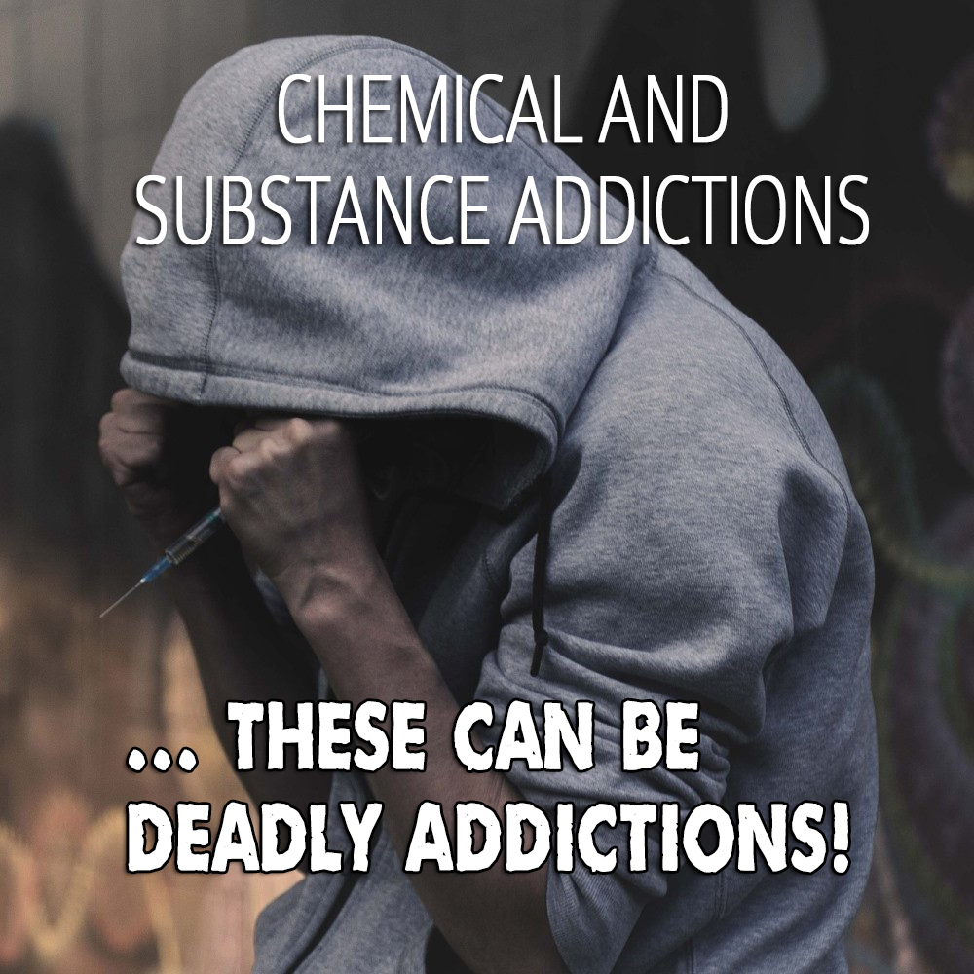

Of course, there is the long-standing debate on whether “addiction” is simply a lack of will-power, personal strength and moral principles versus it actually being an actual disease.

Naysayers believe the person abusing drugs or alcohol should be able to just quit at will, especially after noticing negative consequences.
In some cases, those with addictions can stop on their own and lead a perfectly normal life. There are also those who require professional help.

Studies have proven many times over that chemical and substance addictions have both physiological and psychological components. Researchers have provided irrefutable evidence on how the brain changes over time with continued drug and/or alcohol abuse.

Instead of assuming those in active addiction are inadequate or immoral, we should first try to understand the process of addiction, both on a physiological and psychological level.

Addiction is a Disease

Addictions have been classified by the American Medical Association and the Department of Mental Health and Substance Abuse as a chronic “relapsing” disease for many years now.

Chemical and substance abuse addictions are typically characterized by compulsive seeking behavior and the inability to control the compulsions despite harmful ramifications.

It is commonplace for an addiction to begin as a seemingly harmless recreation or experimentation. The decision to try a chemical or substance is most often voluntary. Persistent use causes changes in the brain which interferes with the person’s ability to step away and utilize self-control.

The Dopamine Game

The human brain is equipped with a “reward pathway” or “reward circuit” which is activated by the creation of dopamine. This reward system governs how the brain interprets joy, euphoria, motivation, reinforcement learning, fear, and other cognitive processes.

When a chemical or substance is ingested and it breaks the blood-brain barrier, the brain reacts with positivity thus creating a surge of dopamine.

Sounds complicated but it’s actually very simple. Dopamine controls the body’s capacity to feel pleasure and seek a repeat of that same experience. Here’s where the brain plays tricks on the body.

Let’s say a drug is taken, dopamine is activated, and the person feels the “high” or euphoric state of mind. This is interpreted as good by the brain.

Now the brain wants more, and more it shall have. But now the brain adjusts to the amount of drug being provided over and over again, so it cuts down on the production of dopamine.

The same amount of the drug that once brought on so much pleasure and motivation to repeat the use isn’t quite enough to jumpstart the dopamine production.

So what happens next? The addict needs a greater amount to achieve the same level of euphoria as in the beginning.

On the flip side of the tolerance level, one should also consider how the decreased production of dopamine affects other activities like spending time with family, having a social life, or even eating.

The dysregulation of dopamine also causes the addict to get less pleasure from things they once enjoyed. If there is no joy, there is very little desire to repeat these activities.

Physiological Effects

According to the Diagnostic and Statistical Manual of Mental Disorders, physical dependency, or addiction, has certain criteria:

- Continued abuse of a chemical or substance despite negative outcomes.
- Tolerance has entered the scene and the “high” is harder to achieve.
- Withdrawal symptoms surface if the chemical or substance is unavailable.

After a person has become physically addicted to a chemical or substance, the body can become violently ill if it does not get a fix. In some circumstances, stopping drug or alcohol use abruptly and without professional assistance can even be deadly.

Psychological Effects

Addiction is often birthed as a coping mechanism for an underlying condition. Meaning, some chemical and substance addictions are started due to the inability to cope with stress.

Drug and/or alcohol addictions alter the mood offering greater self-confidence and feelings of elation and happiness. Being psychologically addicted to a chemical or substance has several noticeable symptoms, including:

- Cravings – The mind needs the fix to feel, or not feel.
- Loss of Control – Stopping the addiction is out of reach and life becomes unmanageable.
- Withdrawal – Without the chemical or substance feelings of anger, irritability and self-loathing appear.
- Impairment – Judgment and the ability to make sound decisions becomes impaired.

It would be a great disgrace not to also address the “relapsing” potential of chemical and substance addiction. Relapse is astounding and happens to more than 50% of those in recovery.

It is crucial to understand and accept the fact that treatment is a continuous and lifelong commitment to stay in recovery.

It sounds daunting indeed, however if chemical and substance addiction is looked upon like any other disease with the potential for relapse, like diabetes or kidney disease, the need for maintenance is always there and easier to swallow.

The ultimate goal is a happy, productive and fulfilling life; very much worth the work.

Internet, Smartphone and Gaming Addictions

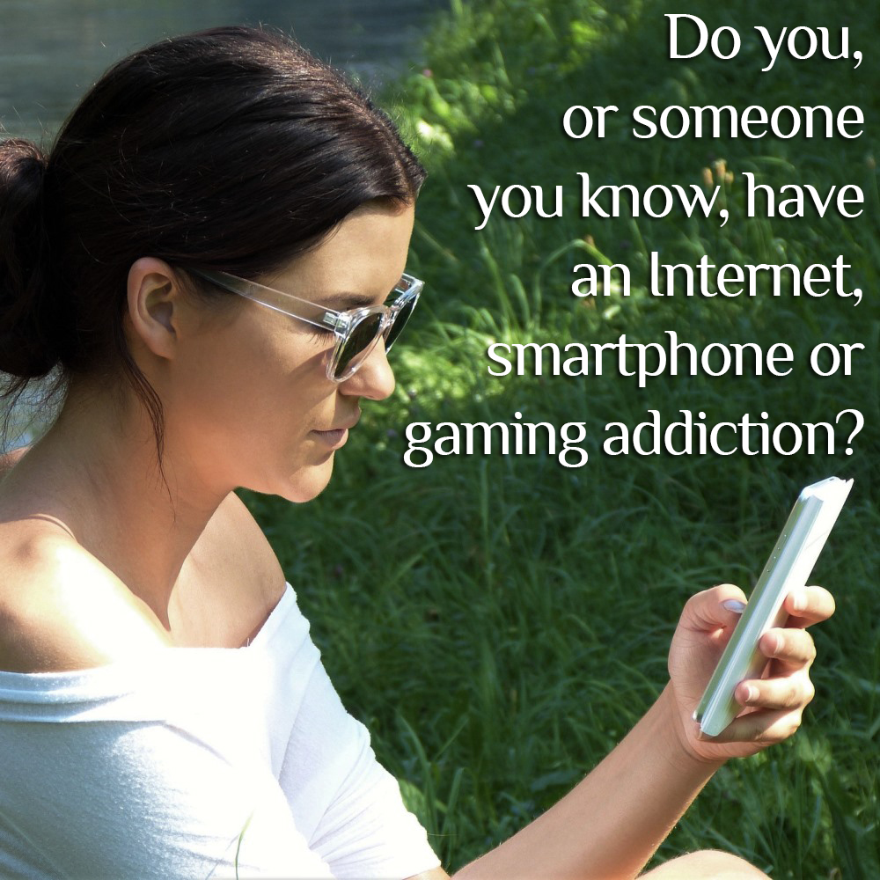

Who could have guessed the Digital Age would ultimately create an entirely new series of addictions?

Over the last 40+ years, since the first personal computers and gaming systems hit the market, our society has become somewhat dependent on screens.

And if the screen is mobile, even better! What we didn’t predict was exactly how much we would end up relying on these screens, both for business and pleasure, and the propensity for addiction.

Internet Addiction

Being “connected” used to have an entirely different meaning before the internet took over. At one time it meant having a relationship with influential people, either in a family sense or the business world, who could move mountains and get a job done.

Today, being connected is just another term for having internet access. With internet access we basically have the world at our fingertips. We can pay bills, shop, gamble, play games, find dates, order dinner, email, video call, and even find out where our children are within a 400 ft radius. The possibilities are endless.

It’s not all it’s cracked up to be for some people. It’s all fun and games until it becomes a full-fledged addiction.

Signs of internet addiction include:

- The amount of time spent on the internet keeps increasing.
- Anxiety rises if not “plugged in” or anticipating being “unplugged” for a period of time.
- Interference with normal responsibilities; ie. work, school, chores/errands, meals.
- The desire to use the internet is greater than the desire to engage in social activities with friends and/or family.
- Inability to cut back or stop.
- Excuses arise to validate the amount of time “connected”.
- Attempts made to hide the true nature of behavior while online.
- Loses all concept of time while engaging in online activity.

It’s one thing to take a couple minutes watching a video of a baby elephant playing in a kiddie pool. It’s a problem when one is still sitting there four hours later researching how to rebuild a tractor engine when they have neither a farm or a tractor in need of repair.

Smartphone Addiction

Similar to basic internet addiction, the Smartphone seems to have taken connectivity to a whole new level. However, the size and mobility of a Smartphone create an irresistible combination for many.

Smartphone addiction seems to affect more of the younger generation but that certainly doesn’t rule out the middle age and older groups. There’s a certain amount of security offered in having a Smartphone in one’s pocket. That little gadget has apps for everything. The weather status is just a tap away.

So is summoning an Uber or Lyft to get home after a night of drinking. Maps are great for navigating a new city or checking the road conditions when a traffic jam surfaces out of nowhere. Emergency services are always available as well.

The signs and symptoms of Smartphone addiction are the same as internet with the addition of a couple more:

- Interrupting or ignoring others to use the Smartphone.
- Attention deficit issues.

The human brain can take a lot. It’s pretty amazing. But constantly shoving information at it from every direction on a tiny screen actually decreases the brain’s ability to focus on a single task to completion.

Gaming Addiction

There is much controversy among professionals whether gaming can become a true “addiction” or not. In a sense, casino style slot machines are essentially games. So is poker. And gambling is in fact recognized as an addiction. Video games may not have high stakes, but they are still games.

Virtual games that allow the player to escape reality for as long as they are plugged in. And that’s really where the bigger problem lies, isn’t it?

Unlike the two addictions above, gaming addiction actually prevents the gamer from being productive. With internet addiction or Smartphone addiction, the user has the ability to remain in the here and now to a certain degree.

Of course, their attention is split between their addiction and what’s right in front of them. The gamer is solely concentrating on the next battle or stage of the game. Nothing more, nothing less.

Below are some common issues related to a gaming addiction:

- Social isolation
- Sedentary lifestyle
- Increased aggression/violence
- Stunted personal development

One could argue the multi-player video games create a social circle of people with like interests. However, wearing a headset and taking on the persona of a character in a video game hardly make up for actual human interaction and conversation.

It should also be noted, the aggression and violence issues related to gaming is not really a factor for games like The Sims. The thrill in games like The Sims isn’t stemmed from stealing cars or shooting at people, but from creating an entire virtual life from the ground up.

Addiction is addiction, plain and simple.

No matter the addiction the criteria are the same: compulsion, obsession, inability to stop and withdrawal. And the ultimate goal is to live life free of controlling and over-powering addictions.

Sexual Addiction

Let’s get down to the nitty gritty and talk about sexual addiction. Brace yourself. It’s a real thing, sex addiction.

Just like any other addiction, if the four components are present (compulsion, obsession, inability to stop regardless of negative consequences, and withdrawal), it’s going to take hard work, self-reflection, self-control and more often than not, professional help.

Like with many other forms of addiction, sexual addiction is a cover. Children act out when they don’t know how to communicate their feelings, desires or pain. With adults, addictions form usually as a coping mechanism.

There’s most likely something hidden deep within we either don’t want others to see or we are afraid to see ourselves.

What is Sexual Addiction?

There are a couple of challenges in defining sexual addiction. First, a moral compass for one could be completely different for another. For instance, Sally believes she should be abstinent until she’s in a committed relationship.

Her buddy Karen prefers casual sexual partners, always practices safe sex and might have more than one partner in any given week. Sally considers Karen to be a sex addict even though Karen clearly does not meet the four key components of addiction.

Second, porn addiction could be lumped under the sexual addiction umbrella, except that someone addicted to porn is not interested in sex with partners. In fact, once a porn addiction is in full-swing, the addict typically needs to see porn before reaching a state of arousal to actually have successful intercourse with another person. On the flip side of the coin, both porn and sex addicts engage in frequent masturbation.

For these reasons, the exact definition of sexual addiction is fairly broad: Sexual addiction involves a continuous preoccupation/obsession with sexual behavior and fantasies regardless of consequences.

Sexual addicts typically feel great shame after a sexual encounter and are unable to quit or put limits on their sexual acting out despite repeated attempts.

Signs and Symptoms of a Sexual Addiction

For an addiction to be alive and kicking, the addict will likely spend a great deal of time seeking the next sexual encounter.
Even in social situations, their mind is preoccupied with the thoughts of sex and when their next “fix” will take place.

Their life is consumed with thoughts of the next time and how to get there, reorganizing their life so it is certain to happen. The likelihood of a sexual addiction is prominent when three or more of the following apply:

- Persistently craving sex
- Spending a great amount of time in activities related to sex and sex fantasies
- Neglecting other obligations and responsibilities; i.e. work, school, family and social
- Continuation of sexual encounters despite negative consequences; i.e. relationships in turmoil, potential health hazards, criminal charges
- Increased frequency of sexual encounters to get the desired effect
- Irritable, angry, depressed or anxious when unable to engage

Are There Risk Factors for Sexual Addiction?

You bet! As with all addictions the way a child was raised and what the child was exposed to has a great deal to do with what type of adult they will be. Kids with exposure to sex and porn have a greater chance of dealing with sexual addiction as an adult.

Also, children who have suffered sexual abuse or other trauma have been shown to be more promiscuous as adults and have increased probabilities of developing a sexual addiction later in life. Other risk factors include having a first degree relative with a sexual addiction and socioeconomic status.

Complications and Consequences

As mentioned above, those afflicted with sexual addiction often feel extreme guilt related to their sexual escapades. Their conquests are merely a means to an end. There usually isn’t much of a romantic component; straight and to the point – sex is the only objective.

And here’s the kicker: They aren’t seeking sex to feel good or experience the euphoria with orgasm; they are trying to feel less. With that in mind, it’s easier to grasp the concept that sexual addictions can range in activities anywhere from voyeurism to bondage and masochism.

Sex is normal. Humans naturally crave sex. Without it, humanity wouldn’t survive. However, sex in inappropriate places or risky sexual behavior isn’t natural, and sometimes illegal.

A person with compulsive, uncontrolled sexual behaviors is likely to suffer severe consequences.

Such as:

- Infidelity.
- Relationship troubles, including family and friends.
- Inability to concentrate on work or school.
- Unwanted pregnancy.
- Financial issues. (Paying for prostitutes can get pretty expensive. So can legal costs to keep themselves out of jail.)
- Risk of sexually transmitted disease, including HIV and AIDs, from having unprotected sex.
- Legal consequences. (See financial issues.)
- Anxiety/depression, OCD-type symptoms and emotion dysregulation.

Substance abuse seems to be a rampant co-occurring addiction in those with sexual addiction. If left untreated, it can lead to a very dysfunctional lifestyle. Recovery from sexual addiction is possible and worth the work to lead a healthy and productive life.

Shopping Addiction

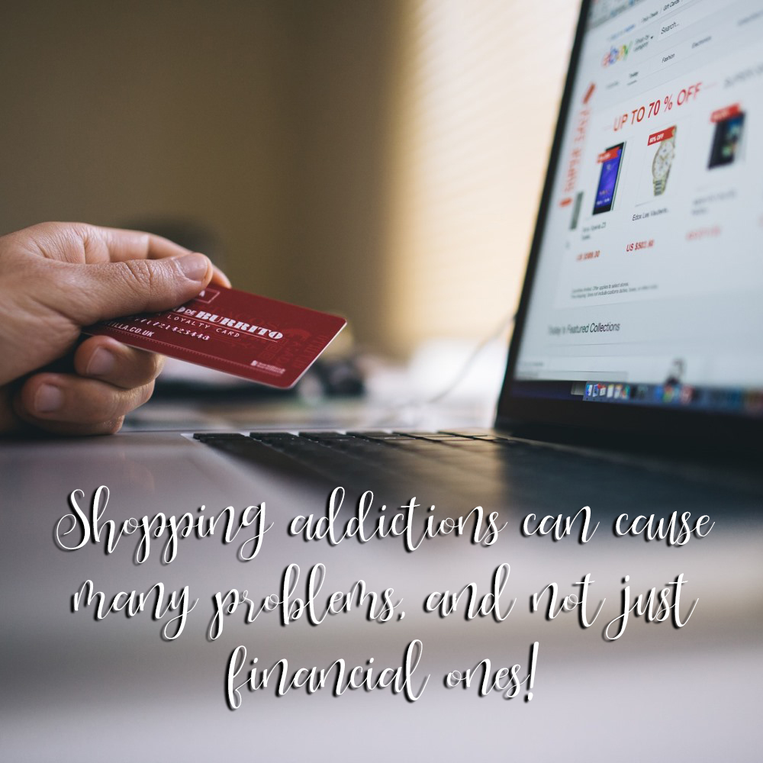

Everybody shops. It’s a part of life. We shop for food, health and beauty aids, clothes and shoes. Home décor, hobby supplies, appliances, cars and more!

Pretty much everything in our lives is either purchased or handed down from another.

There’s a thrill in buying something new. Shopping for many is entertaining and a positive activity.

The people walking around the mall, perusing the stores and checking out the sales, certainly don’t have scowls on their faces. They are happy! Shopping makes people happy! Shopping addiction though, is a completely different story.

Risk Factors for Shopping Addiction

Studies have shown shopping addiction to affect predominantly women and it starts in the teens to twenties, after credit cards are readily available. Evidence also suggests compulsive shopping tends to run in the family, and is usually co-occurring with another mental health issue, especially depression.

Substance abuse and addiction is common in one with a shopping addiction as well.

Phases and Type of Shopping Addiction

This isn’t just a simple “over-buying” disorder. Those dealing with shopping addiction have a deep emotional connection to the act of purchasing.

There are five common phases:

- Urge: Can’t stop thinking about shopping.
- Prep Time: Research to find the perfect item and deciding which card to use.
- Shop: Intense elation during the shopping experience.
- Pay Up: The purchase is complete and euphoria is achieved.
- Regret: Guilt takes over. Especially if the item just bought has to be a secret.

Now take a look at the types and different reasons for shopping:

- Compulsive Shoppers do so to avoid emotional distress.
- Bargain Basement shoppers look for deals and sales, buying things they don’t need simply because it’s a deal they can’t pass up.
- Trophy Shoppers look for the best of the best; the perfect item.
- Big Spenders are always trying to out-shine others with expensive, flashy items.
- Collectors shop for sets of things and feel a sense of loss and emptiness until the set is complete.
- “Bulimic Shoppers” create a terrible cycle of buying and returning purchases.

Every shopping addict has their own set of circumstances and reasons for the compulsive behavior. And when the purchases can no longer be justified, they shop privately and hide the items.

It’s also common for a person with shopping addiction to impulsively buy and then forget about the item once it gets home. It might even stay in the original packaging and get put in a closet. In their mind, one day in the future those things will be needed or useful.

Consequences of Shopping Addiction

Just like any other addiction, there are always consequences, a lot of which are negative. Despite these undesirable ramifications, the shopping continues.

Below are several common repercussions:

- Extreme debt and inability to pay other living expenses
- Guilt and regret from the purchases and hiding the addiction from loved ones
- Distress in personal relationships
- Bankruptcy

Those with a shopping addiction, after maxing out credit cards and using all disposable income will then look to other options; taking out loans, getting a second mortgage, borrowing from friends and family, or even stealing if no funds can be secured.

The list of consequences doesn’t stop there.

Let’s take a look at the emotional and physical impacts one might see with a shopping addiction:

- Persistent state of depression; sad, empty, lonely
- Self-loathing and feeling worthless
- Hopelessness
- Inability to make sound decisions
- Difficulty with concentration and memory
- Restlessness and trouble sleeping
- Appetite changes or changes in weight
- Loss of interest in other activities that once brought pleasure
- Paranoia (related to hiding purchased items and keeping the addiction a secret)

Treatments

A love of shopping is completely different from a shopping addiction. The impulsive buying and inability to stop regardless of the outcome pretty much distinguishes the two. Fighting the addiction is quite a chore because people will always have a need to shop for something.

Not everyone will need to seek professional help. It all depends on the individual really. If professional help is necessary, there are psychologists offering CBT (cognitive behavioral therapy), inpatient and outpatient treatment centers and support groups.

To help with cleaning up the financial aspect, one might consider contacting a debt consolidation company or even an attorney to see if bankruptcy is an option.

There is help readily available for those willing to put in the work necessary to be successful.

Don’t give up! A happy, productive life is just around the corner!

Work Addiction

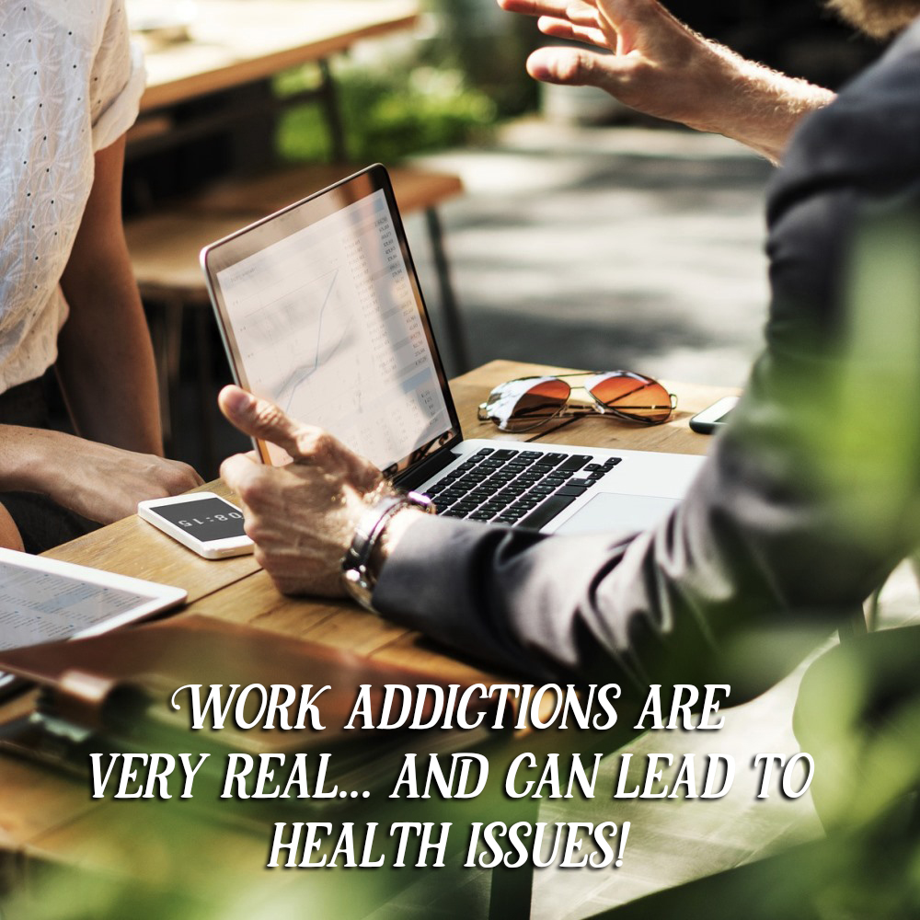

Being committed to a job and taking pride in a job well done is very different from having an actual work addiction. Our culture is ever-changing and the economy continuously fluctuates.

It’s important in a competitive market to be disciplined and maintain a superior work ethic.

But what about the people who essentially dedicate their entire lives to their work?

Not the typical motivated go-getter who gets results but the person who is always early, stays late, works through breaks and lunch, takes work home with them and sees very little reward?

Those with a work addiction aren’t driven by the idea of success, notoriety or increased salaries. In fact, studies have shown the work addict is less productive and workaholic traits are not associated with bigger salaries.

While one with a work addiction might try to justify their behavior by saying it will help them achieve success, ambition and addiction are quite different.

Symptoms and Behaviors of Work Addiction

Addiction to work might seem healthy enough, however there are both psychological and physical effects when uncontrolled and untreated.

- Obsessed with work duties and find more joy in being at work than with family or other activities
- Staying later than intended and working long hours even when not necessary
- Fear of failure in the workplace
- Worried about performance and goals at work and attaching unrealistic performance expectations
- Avoidance of stress outside work; relationships, family, crisis
- Coping mechanism to elude feelings of depression, anxiety, guilt, or anger
- Anxiety and irritation arises if restricted from working

By no means is this an exhaustive list, however the concept should be clear. Work addiction is a form of self-soothing wherein the addict cannot ascertain how to make their lives less complicated and more manageable. Work is essentially the safe zone wherein one can delay dealing with or completely ignore what lies just outside the office door.

Risk Factors

There are a number of influences which may contribute to a work addiction. Studies have been limited in giving irrefutable evidence, however some of the most common causes could be related to:

Upbringing - Responsibility is held in much higher regard than achievement in childhood.
Culture - In some cultures, hard work and relentless dedication are emphasized.
Personality – Narcissism and perfectionism, among other personality disorders.
Social - Positive feedback reinforcing tasks which required an exorbitant amount of time and effort.

Effects and Consequences

Work addiction takes a great toll on the body and mind. One might experience concentration and memory issues due to overworking; staring at the same piece of paper or looking at the computer screen at the same information for hours on end.

Prioritizing tasks becomes impossible and duties get jumbled together resulting in missed deadlines and incomplete projects. And when the job isn’t completed in the time allotted or to the intended specifications, worthlessness, defeat, self-loathing and depression sneak in to steal the joy.

But that’s not the end of the story! There is always another project or assignment looming in the background waiting to be consumed by the addict.

And the cycle continues… work, work, and more work.

Home life suffers a great deal. Relationship strife is no stranger to those with work addiction. The addict becomes an absent figure in their own life.

Social circles and family members respond in different ways, each causing their own level of distress and anxiety on the one who would rather be at work.

Fatigue from lack of sleep due to working extraordinary hours is common. When the body doesn’t have time to rest and replenish itself, the immune system isn’t running on all cylinders. A diminished immune system means sick days, and sick days means missed work.

And finally, there’s “burnout”. This is the worst possible thing that could happen to someone with a work addiction. Think of what overdosing does to a drug addict.

For the work addict, “burnout” takes away the one thing they felt was keeping them going. Some suffer a mental breakdown while others experience physical exhaustion; both of which could require inpatient treatment if ignored and left untreated.

It is very possible to have a healthy work ethic and still maintain a life outside work. First, identifying the core emotion or personality trait pushing one into the office is essential.

Understanding the nature of the beast makes it possible to successfully tackle and overcome.

Treatments and Therapies for Addictions

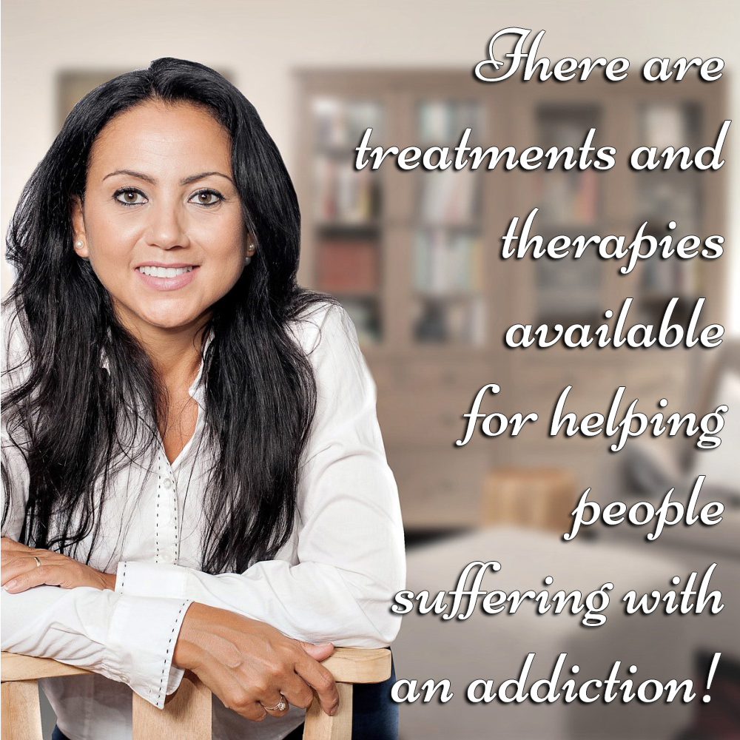

Addictions have become quite an epidemic in our society, and it seems as if it’s only getting worse. Every direction we turn there’s an advertisement about a treatment center for addiction or a billboard on the side of the freeway.

On the news we hear the horrific stories of lives destroyed and lost due to one addiction or another.

It’s quite surprising how few people actually know the options and the readily available treatments and therapies for addictions.

Individual Counseling

For many plagued with addiction finding a licensed behavioral health professional in an agency or private practice setting is the way to go. Counseling is an informal, yet effective method to get on the right road to recovery.

Typically, the provider spends a great deal of time in the first session, the intake, gathering information and discussing goals of the client. The counselor/client relationship is built on trust, so it would behoove the addict to do a little research on the provider prior to making an appointment.

For counseling to be effective the addict has to feel comfortable and safe. Looking for a counselor with specialized training in addiction is a good idea.

Most behavioral health specialists will use CBT (cognitive behavioral therapy) for addictions. In short, CBT is a way of assisting the client to recognize unhealthy thinking and replace it with more helpful options. By reassigning negative thoughts with positive alternatives, the reactions to the thoughts also change.

Counseling may take a few visits to be a more long-term treatment for addiction. It all depends on the individual suffering from addiction.

Inpatient Treatment Centers

On the other end of the spectrum from individual counseling is the option of inpatient treatment centers. These are residential programs designed to treat patients with chronic addiction issues and are adept in treating underlying and co-occurring mental health issues.

Each facility provides its own specific accommodations. Some are very basic, State-funded facilities with very little in the way of amenities, and others are more luxurious. The typical stay in an inpatient facility is 30 days, however this also depends on the needs of the one seeking treatment.

Again, it’s important to make sure the facility chosen for treatment of addiction specializes in the area needed. Most rehab facilities offer individual counseling sessions, group therapy and a variety of other activities like yoga, art and meditation.

After completion of the program, the usual destination is an intensive outpatient program or transitional living. In transitional living the residents are expected to go to meetings, seek employment, and get their lives back on track in preparation for the real world again.

Outpatient Treatment Centers

Oftentimes an outpatient treatment center is the next step after being inpatient, however that’s not always the case. Some are simply not able to go inpatient due to other responsibilities and the next best option is an outpatient treatment center.

These facilities are less restrictive but do require attendance to stay in the program.

The sessions in an outpatient treatment center are focused on addiction education, counseling in both an individual and group setting, and coping skills. Expect to spend at least three months in an outpatient program for it to be effective.

Support Groups

Treatment and therapy options for addiction in this category are effective in both detoxing and recovery maintenance, although typically those in active addiction prefer a more intense treatment plan for the accountability. There is a wide range of support groups for all sorts of addictions.

Here the individual receives peer support. The validation of feelings and emotions by someone who has been through what another is currently going through has very positive effects, especially if there is a happy ending.

In going to a support group an addict is provided with the opportunity to share without judgment. Those in recovery earn tokens or coins for each milestone of sobriety. This aids in encouragement to keep going as a reminder of how far they have come.

Medications

It wouldn’t be a complete list without mentioning pharmaceutical intervention. There are limitations to what medications can do for someone in active addiction.

And chances are medication alone isn’t going to be a successful treatment for addiction and would better serve an addict in combination with any of the treatments and therapies listed above.

It’s important to understand recovery from addiction takes relentless dedication to a new lifestyle.

Treatments and therapies for addictions can only do so much – the addict has to be willing and persistent in their desire for and pursuit of recovery.

Conclusion

Addiction has caused devastating effects to many people. Of course, the addicts themselves have their lives diminished, sometimes to a horrific degree.

However, the ripples of damage usually spread far wider and negatively impact other people also.

Those who love and care for those in the clutch of addiction can be forced into a life of despair and helplessness as they try to help the affected person and protect themselves and others from the affects.

It is hoped that the information provided has given insight into how and why addiction can occur, and especially afforded hope that there can be a way to break free of addiction.

The path is never easy and requires commitment from both the addicted person and those who choose to help them.

Also, depending on the type of addiction, it may be necessary for your own self-preservation and mental wellbeing to remove yourself from the situation, if you are adversely affected by someone else’s situation.

